|  |  |  |  |  |  |  |  |  |
| --- | --- | --- | --- | --- | --- | --- | --- | --- |
| |  | | --- | | Exascend V30 Catalyst 256GB SD Memory Card | | Product image thumb |  |  |  |  |  | | --- | --- | --- | --- | | Product image thumb | Product image thumb | Product image thumb |  | |  | **Specifications:**  256GB storage capacity  Maximum sequential read speed: 180 MB/s  Water, dust and impact resistant  Resistant to impacts from X-rays, magnets and temperature  **Price: 32.9$** |

**Overview:**

**Exascend V30 Catalyst 256GB SD | Memory Card FOTOLAB**

The Exascend 256GB UHS-I SDXC memory card has a design that focuses entirely on durability and data protection. With resistance to water, dust, impact, X-rays and magnets, it helps ensure that data is always protected in all different environmental conditions. Additionally, capable of operating in temperatures ranging from -13 to 185°F (-25 to 85°C), the memory card ensures stability in harsh climatic conditions.

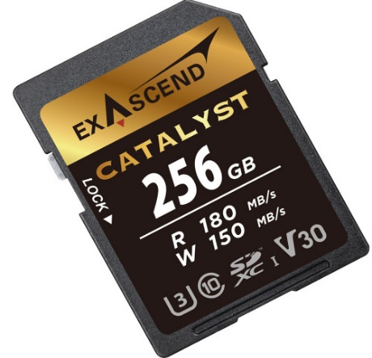

To prevent accidental data loss, Exascend 256GB UHS-I SDXC also has a built-in protection switch, helping to protect your important data. If the user's camera does not support a minimum write speed of 30 MB/s, the card is also compatible with the U1 and Class 10 standards, each of which guarantees a minimum write speed of 10 MB/s.